Test Case: tc008_SPX_Dev5_Validacion_Boton_Remove_Administrador_Menu
Step 1 - Enter username and password and click to button Enter : Credentials Entered
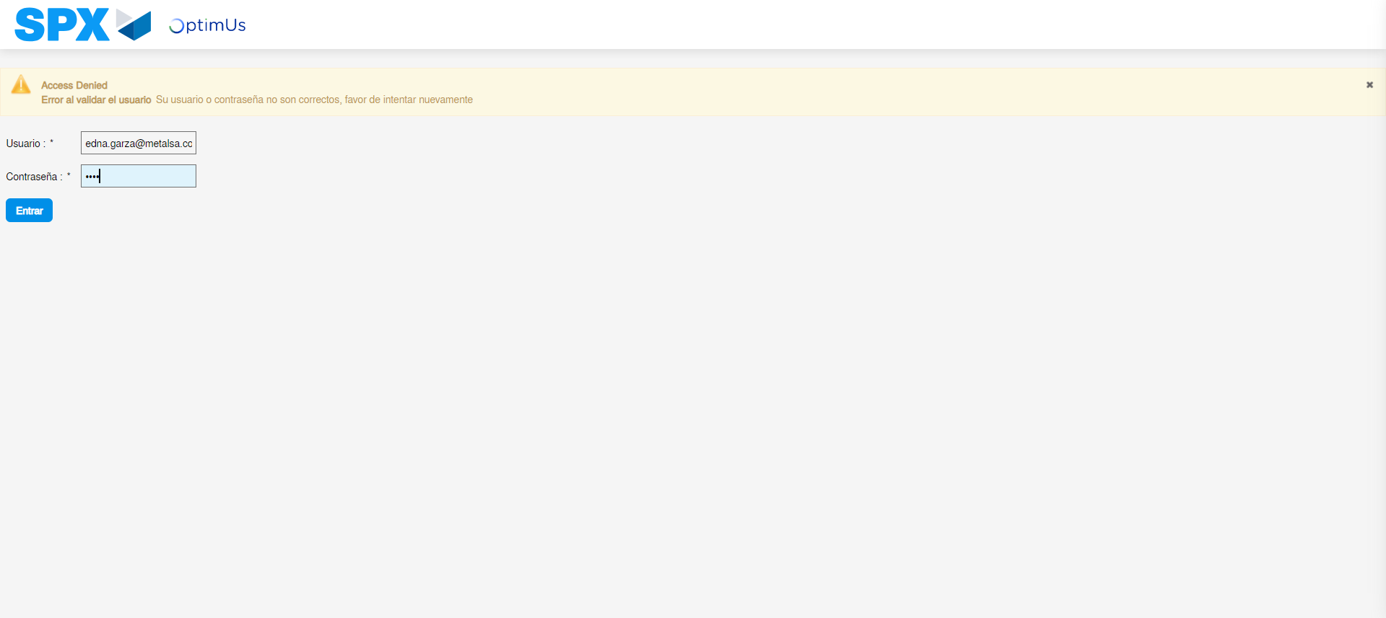Image file-name: QC_Testing-tc008_SPX_Dev5_Validacion_Boton_Remove_Administrador_Menu-may. 15 2024, 01 05 31 p. m.

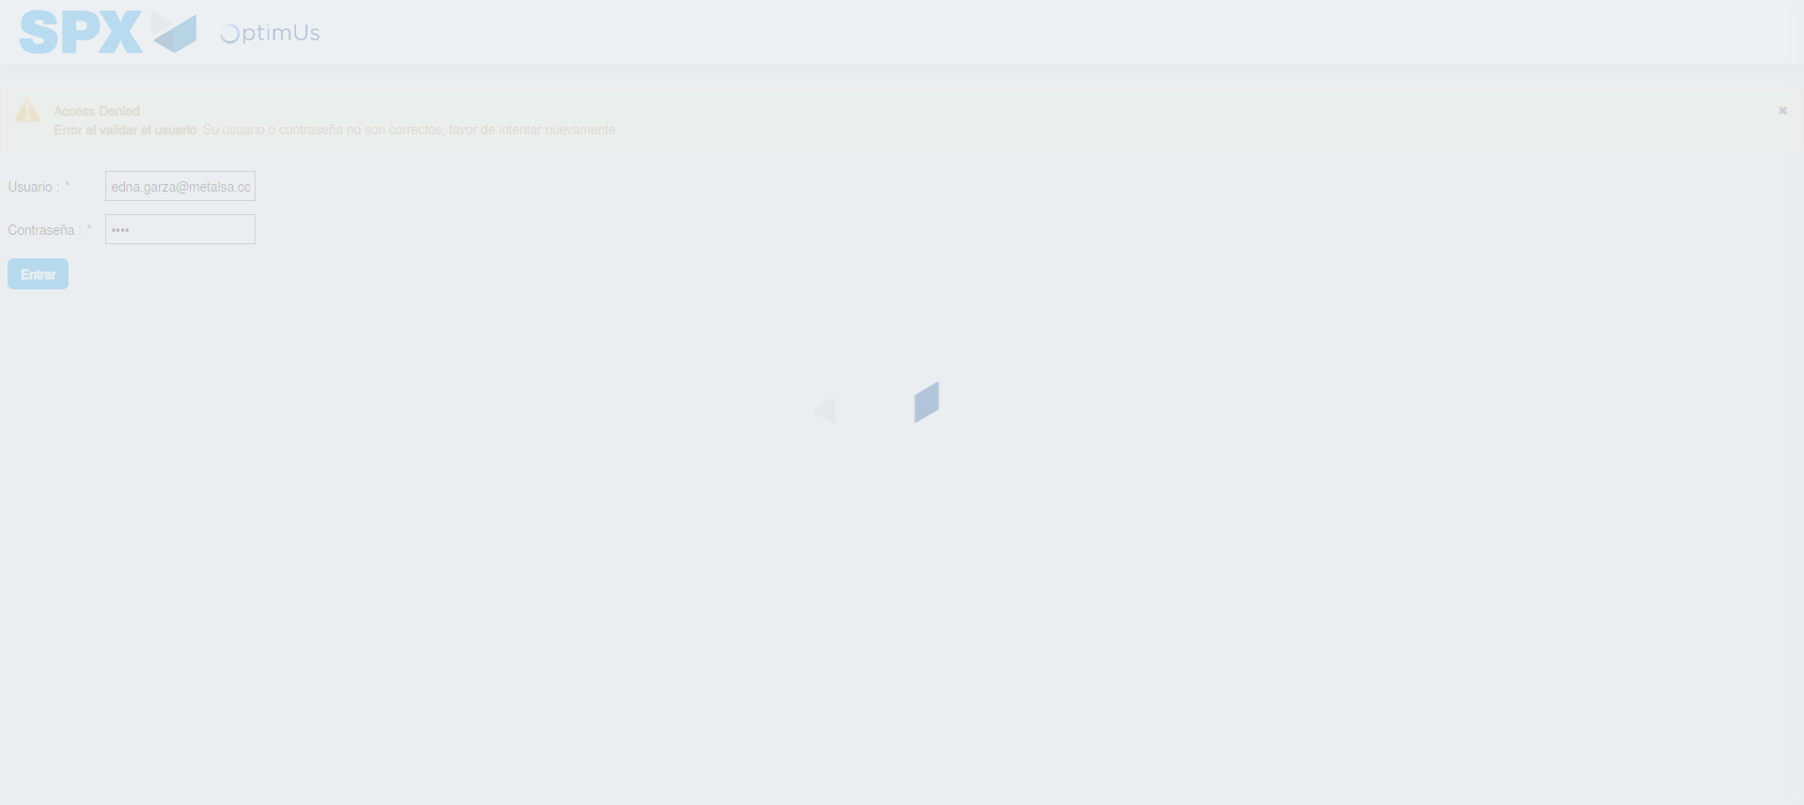Image file-name: QC_Testing-tc008_SPX_Dev5_Validacion_Boton_Remove_Administrador_Menu-may. 15 2024, 01 05 32 p. m.

Step 2 - Select to UEN and Access to Administrador Roles Menu: UEN Correctly selected and Correct access
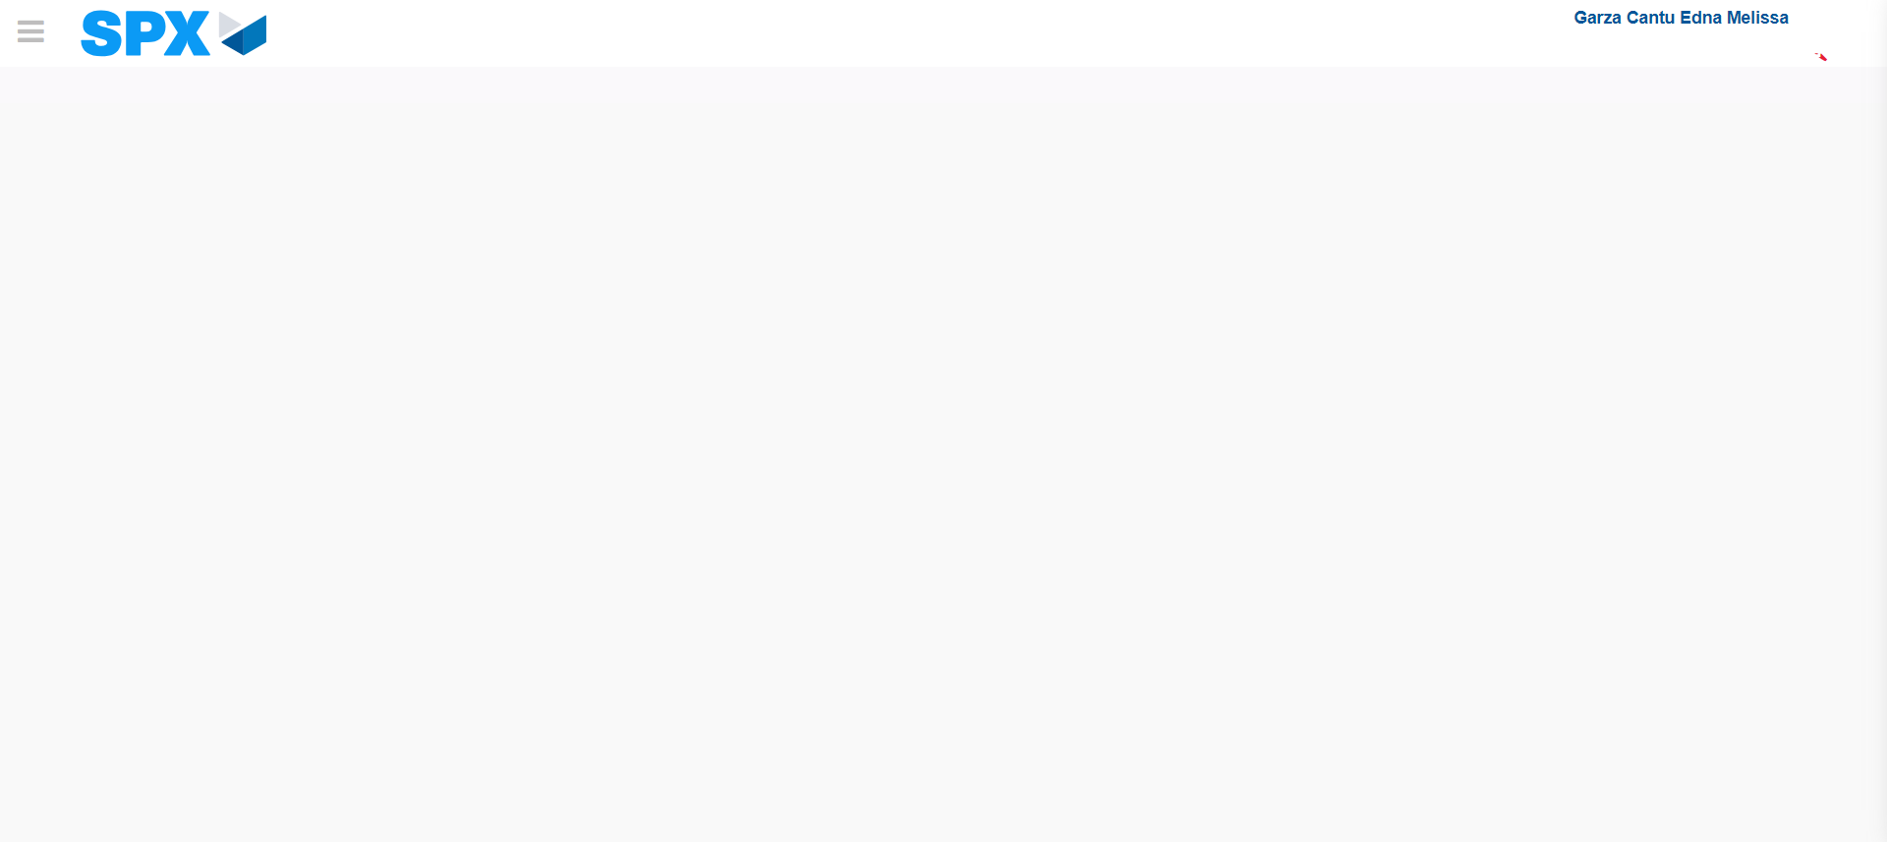Image file-name: QC_Testing-tc008_SPX_Dev5_Validacion_Boton_Remove_Administrador_Menu-may. 15 2024, 01 05 38 p. m.

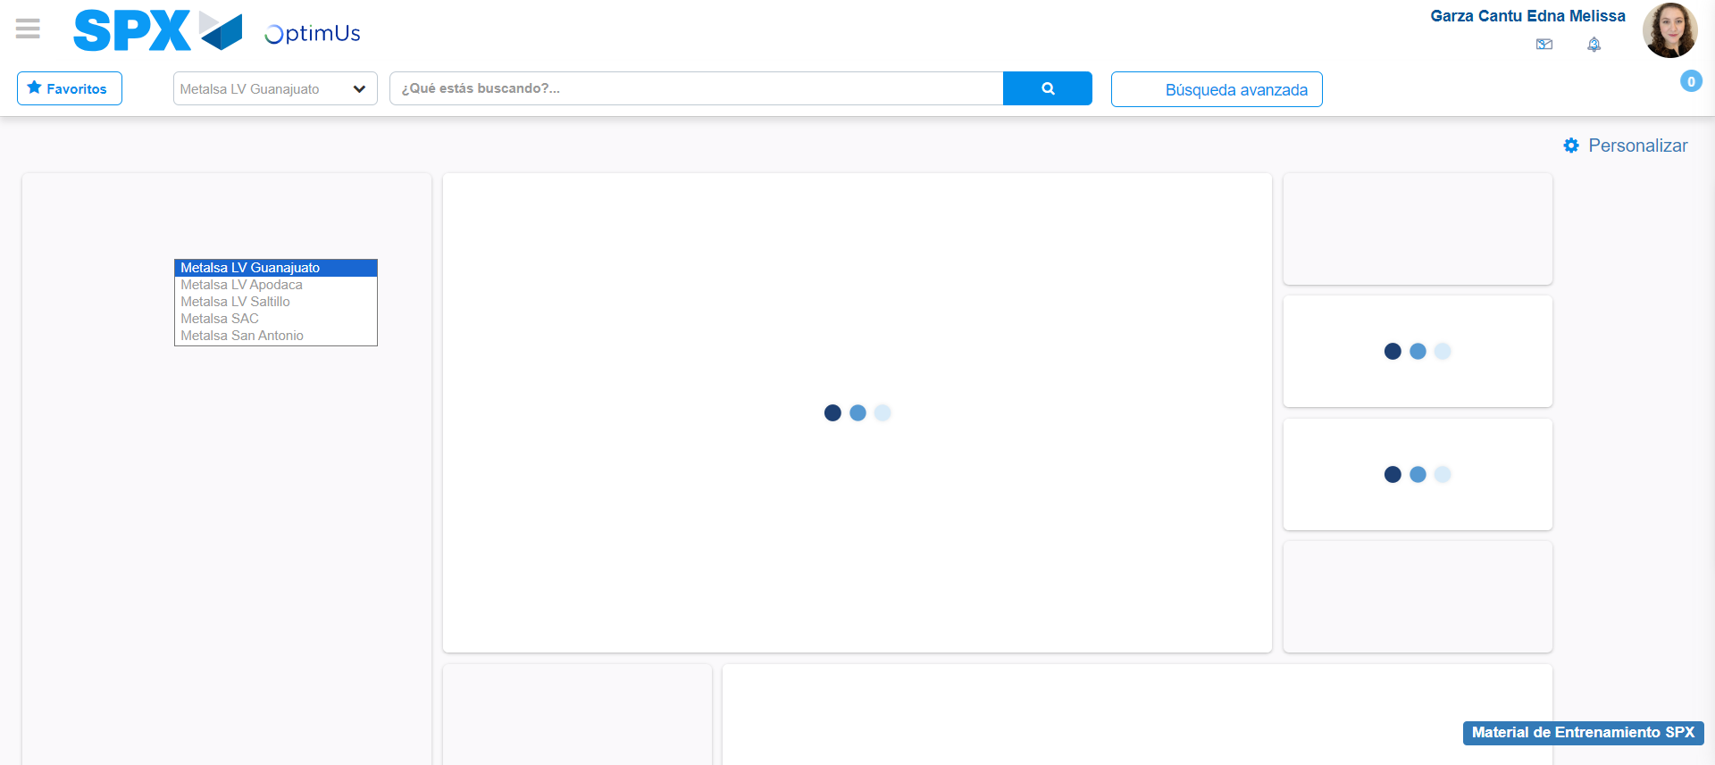Image file-name: QC_Testing-tc008_SPX_Dev5_Validacion_Boton_Remove_Administrador_Menu-may. 15 2024, 01 05 39 p. m.

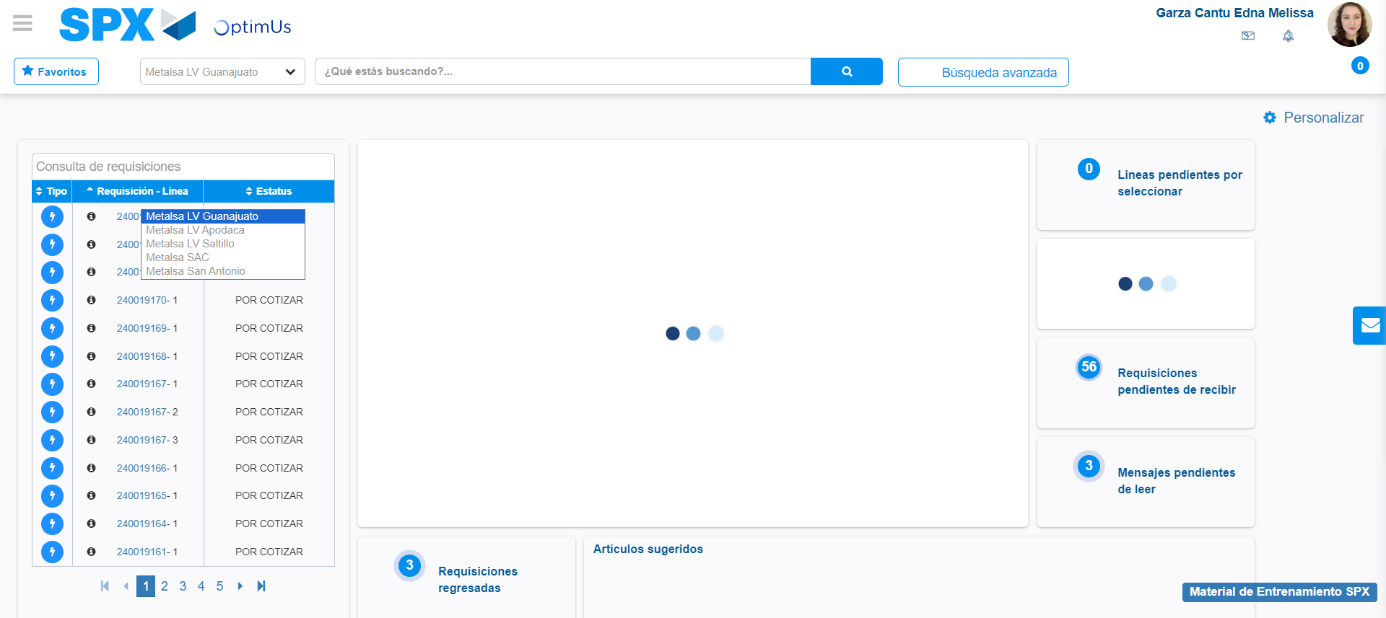Image file-name: QC_Testing-tc008_SPX_Dev5_Validacion_Boton_Remove_Administrador_Menu-may. 15 2024, 01 05 40 p. m.

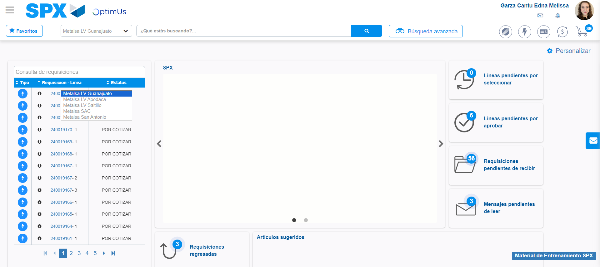Image file-name: QC_Testing-tc008_SPX_Dev5_Validacion_Boton_Remove_Administrador_Menu-may. 15 2024, 01 05 41 p. m.

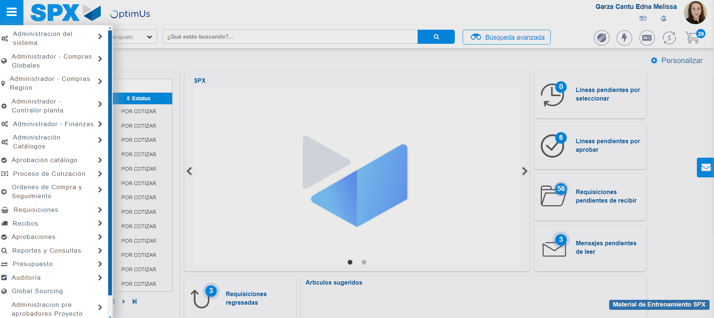Image file-name: QC_Testing-tc008_SPX_Dev5_Validacion_Boton_Remove_Administrador_Menu-may. 15 2024, 01 05 42 p. m.

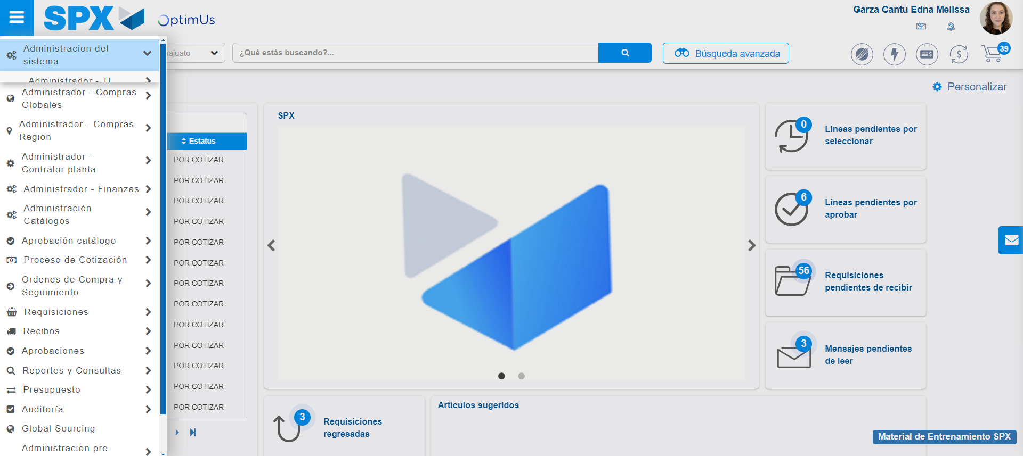Image file-name: QC_Testing-tc008_SPX_Dev5_Validacion_Boton_Remove_Administrador_Menu-may. 15 2024, 01 05 43 p. m.

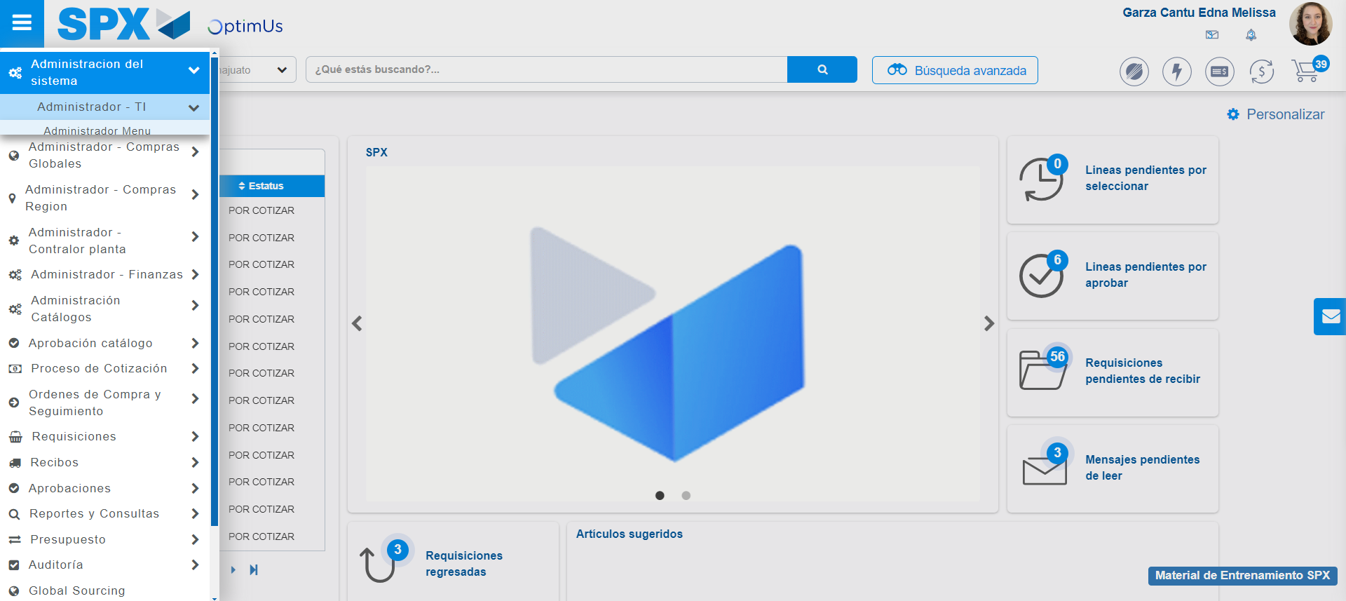Image file-name: QC_Testing-tc008_SPX_Dev5_Validacion_Boton_Remove_Administrador_Menu-may. 15 2024, 01 05 44 p. m.

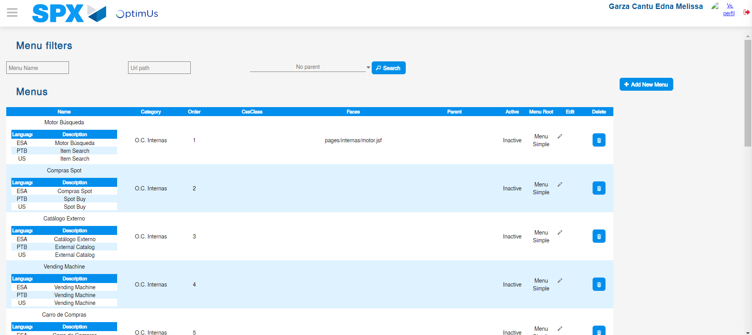Image file-name: QC_Testing-tc008_SPX_Dev5_Validacion_Boton_Remove_Administrador_Menu-may. 15 2024, 01 05 49 p. m.

Step 3 - Delete record: Record successfully deleted
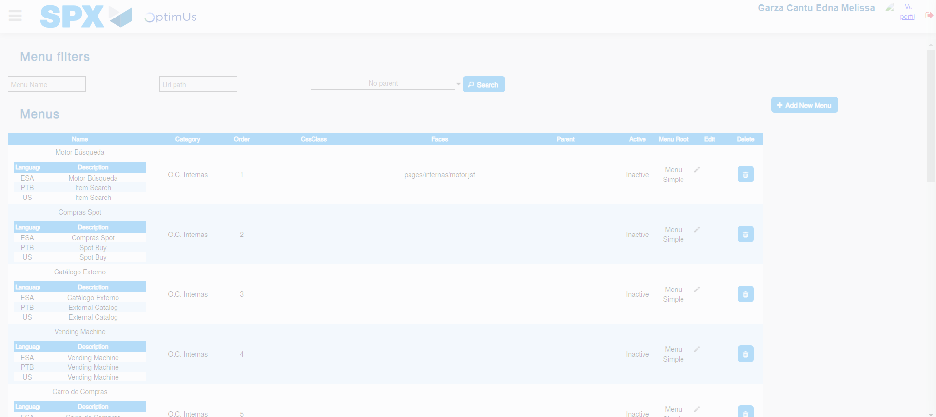Image file-name: QC_Testing-tc008_SPX_Dev5_Validacion_Boton_Remove_Administrador_Menu-may. 15 2024, 01 05 50 p. m.

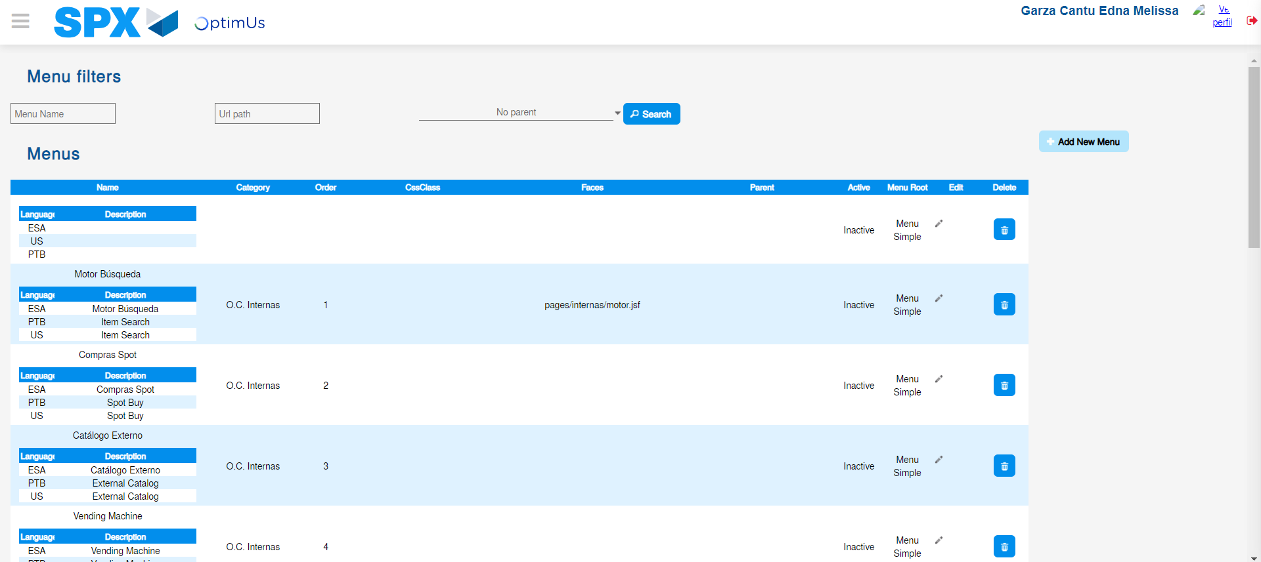Image file-name: QC_Testing-tc008_SPX_Dev5_Validacion_Boton_Remove_Administrador_Menu-may. 15 2024, 01 05 54 p. m.

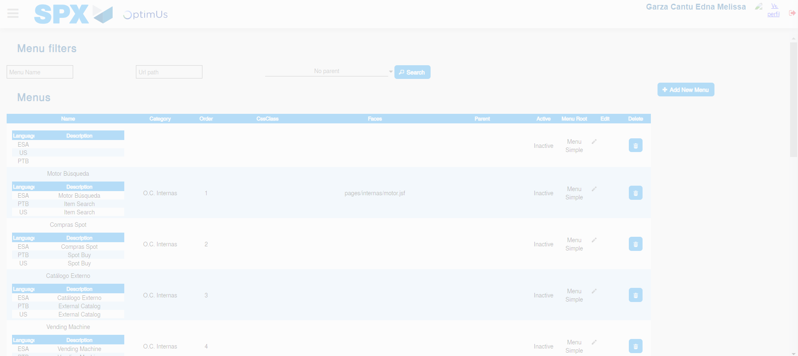Image file-name: QC_Testing-tc008_SPX_Dev5_Validacion_Boton_Remove_Administrador_Menu-may. 15 2024, 01 05 55 p. m.

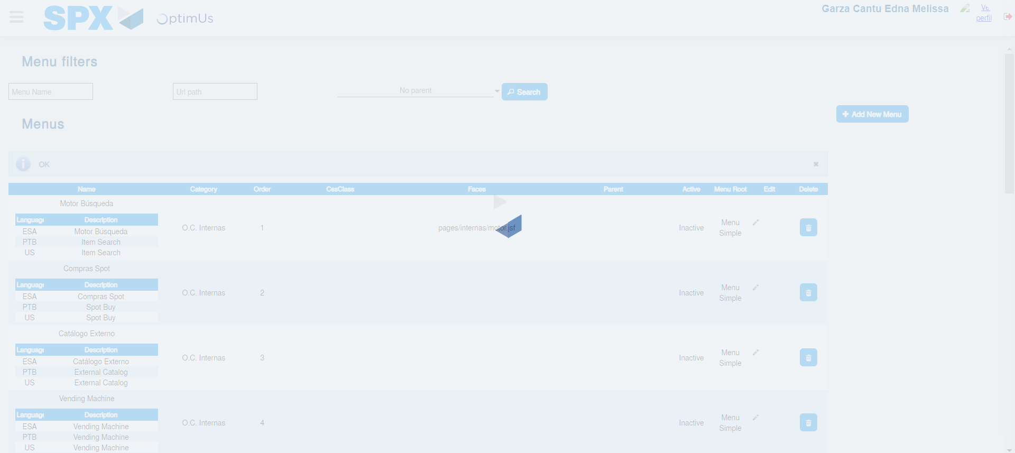Image file-name: QC_Testing-tc008_SPX_Dev5_Validacion_Boton_Remove_Administrador_Menu-may. 15 2024, 01 05 56 p. m.

